As a part of the 2016 European Literature Night (ELN) series*, we are looking for translators who would like to pitch an exciting work with international potential by a European author for our event, The ELN PEN Samples Translation Pitch. The ELN PEN Samples Translation Pitch is open to all translators living in the UK, or in mainland Europe, who have an author whose work they are proposing to translate into English and develop for publication.

The proposals will be shortlisted by a panel of judges, and the top six translators will then compete for the Best Pitch by presenting their project live to an audience and a jury of publishing professionals chaired by Granta Books senior editor Max Porter, who will vote to determine the winner. The winning translator will be offered promotion from English PEN and Free Word. All six shortlisted proposals will be awarded a PEN Samples grant of £250, to be used to prepare a sample translation and reader’s report for publication on English PEN’s website.

The aim of The PEN Samples ELN Translation Pitch is to support and promote the work of European writers who have not yet had a complete work published in English, while providing an opportunity for emerging translators to actively champion the work of their favourite writers in front of UK publishers and literary agents.

Please submit your pitch by completing the form and send it together with your sample translation as two word documents to eln@eunic-london.org, by Monday 7 December 2015.

- Translators must be resident in the UK or mainland Europe
- The proposed European writer must not yet have had a complete work published in English (extracts published in anthologies and magazines are acceptable)
- The proposed extract should not be published prior to The ELN PEN Samples Translation Pitch event
- The submitted proposal must not have been entered for The ELN Translation Pitch 2014
- The translator must check that the English translations rights are available and seek permission from the rights holder to pitch the book at this event
- The original publication date of the proposed work must be later than 31 December 2000
- A sample translation of a maximum of 1500 words in Word format must be submitted together with an application form
- Nominations will be considered by a panel of judges who will select the best six proposals based on the literary quality and strength of the project. Submissions from languages that are translated and published less often into English are strongly encouraged.
- Translators must be available to pitch at live event on 9 June at the Free Word Centre in London. The six selected finalists will be provided with pitch guidance prior to the event. Each pitch will include the reading of an extract by a professional actor.

For queries about ELN or the nominations, contact eln@eunic-london.org. Please download The ELN PEN Samples Translation Pitch Application form from www.europeanliteraturenight.co.uk.
The ELN PEN Samples Translation Pitch is organized by the Czech Centre London and English PEN in partnership with Free Word, the Translators Association and the Emerging Translators Network.
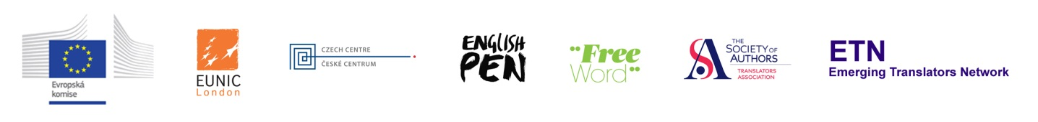-------------------------------------------------------------------------------------------------------------------------------------------------------------------------------------------------------------------------* European Literature Night (ELN) is the annual literary series of events bringing the best of the continent’s authors to the UK.. ELN is a EUNIC London project coordinated by the Czech Centre, supported by the Representation of the European Commission in London and carried out in partnership with the British Library. ELN in London is part of a number of simultaneous events across European capitals and major cities in celebration of European literature.

UK |  | World English
(maximum of 200 words)

(why this book should be published in English, maximum of 200 words)

(previous books, sales history, prizes, other translations, films based on the work, quotes from reviews etc.)

(maximum of 200words) (what the book is about, what material it covers, main argument etc)

Sample translation: Attachment in word format of maximum 1500 words

Please send your application form and a sample translation to eln@eunic-london.org
as two word documents titled:

name_surname_writer’s name_book title in English_form

name_surname_writer’s name_book title in English_extract

Declaration: There is currently no signed contract for this book to be published in English translation and the translation is yet to be commissioned. If the book is selected for the pitching forum I ……………………..( print name) agree to pitch the book to the jury and audience at the ELN PEN Samples Translation Pitch event.

